## Paper Bag Puppets

*Lynne, 21 year veteran,   
Den Leader Breakout Session Leader  
 Old Colony District Roundtables*

**Materials required:**

* 1 paper lunch bag, approx 5.5 inches by 10 inches
* Printout which includes head and body or a good imagination to help boys draw what they want
* Crayons, colored pencils, etc for decorating
* Scissors, tape or glue



**Directions:**

The puppet is made using the rectangular bottom of the paper bag for the face of the puppet, with the flap still mostly folded down. By putting a hand in the bag and curling fingers down over the fold, you can make the puppet 'talk.'

Each puppet comes with two sheets of paper, which have the head, the chin/mouth, the body and arms and legs printed on them. Also in the lower comer is a reference graphic of the assembled puppet.

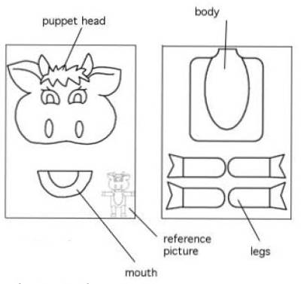

**Make your puppet:**

1. Color the head, mouth, body and limbs.
2. Cut out the different parts.
3. Attach the head to the bottom flap of the bag You might extend the puppet 's nose a bit past the bottom edge of the flap. DO NOT put any glue on that part, you want the flap to move freely. Some heads, like a bird or mouse, might have a beak or nose that will extend below the flap edge.

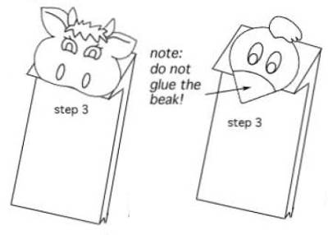

1. Position the body on the bag, fasten in place,

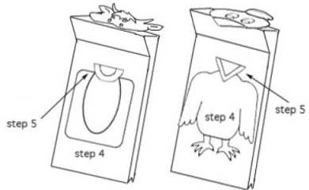

1. Position the mouth; it is attached to the base of the bag, and will generally cover the neck of the body, For some animals, such as the cow shown, you will want part of the lips/mouth to show even when the mouth is 'closed', For other puppets, like a bird, the lower mouth should be aligned behind the beak/mouth of the head.
2. Attach any arms/legs/wings as needed.

